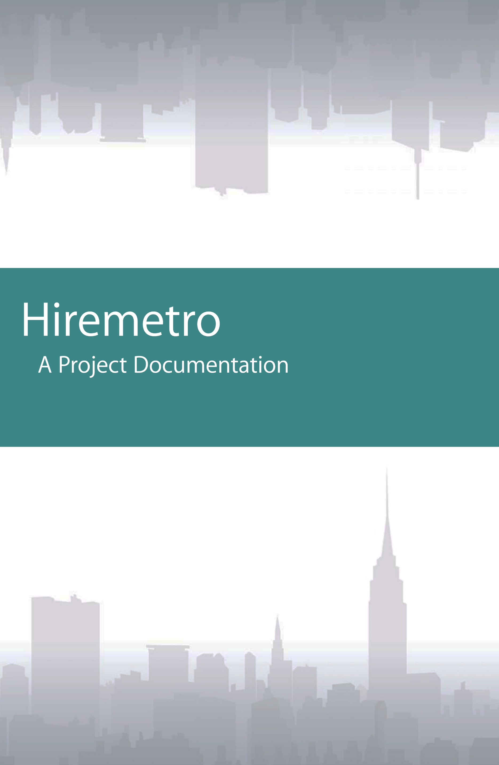



Team Composition

**Leader:**

John Mher Dhexs Emotion / @Jhaym04

Role: Project manager,

Front-end and back-end developer,

Database administrator

**Members:**

Celine Joy Q. Macaraeg / @celinemacaraeg

Role: Front-end Developer

Czar Joshua M. Mamawan / @rarkzem

Role: Front-end and back-end developer

Database administrator

Elvin C. Marin / @ecmariin

Role: Front-end and back-end developer

Lei Dian T. Mendoza / @leidianm

Role: Layout Designer

Front-end Developer

Christian James D. Navarro / @navarrochristianjames

Role: Front-end Developer



**Project Brief**

In today’s world, there are estimated 3.2 billion people in the world who were connected to the massive network called Internet, already half of the world’s population. And in Philippines alone, there are 44+ million Filipinos who were connected to the Internet. Made for the use of military at the first place, the Internet had evolved and have been made available for the public commercial use since mid-1989.

People just doesn’t use it for just communicating by electronic mails, but for many kinds of stuff like improved communication through video calls, or for entertainment like audio and video streaming. There also goes the use of it for the businesses like e-commerce and advertising which had widely changed the face of business forever. With millions of uses for the Internet, there goes the birth of the need for developers.

Take a dive and see the world in a web developer’s view with the help of basic knowledge and skills that will illustrate the building blocks of a working website one by one. By using the basic languages and extended imagination of yours as your primary resources, you will be able to nail the essential concepts needed for web development. This project documentation intends to show the detailed construction of a simple working website as a requirement for the web development course starting from scratch up to the finished working version with use of HTML, CSS, PHP, Bootstrap, CodeIgniter and MySQL.

**Introduction**

Hiremetro is a proposed job portal website designed to help people get their needed manpower which on the other hand, also helps other people who are looking for a job. The main idea of the website works like a digital “classified ads” section of a newspaper, but it is built in the opposite way. Instead of posting ads for job vacancies, the website allows posting ads of employee profiles instead so that people can find and get the manpower they need while at the same time, making it easier for employee to get a job by posting their profiles.



**Project Objectives:**

The website of Hiremetro is specifically made to meet certain goals to fulfill its main purpose. The primary objectives of the website are as of follows:

* Give the ease of finding manpower for people especially in urban areas like a big metropolis where finding specific manpower is a difficult job.
* Lessen the time and effort wasted in finding manpower that people need.
* Provide help to vacant employees to get a job by making them easier to find and hire, especially those who have blue-collared jobs.
* Make people feel the assurance of safety by providing them fine and selected employees that they can hire.
* Promote the vacant employees more by providing discounts and freebies for the users to boost the transactions that will be made.
* Encourage people to make comments and suggestions about the employees and the website to improve the quality of service.
* Allow the employees to manage their accounts further more to fix their profiles.



**Target Audience**

The website of Hiremetro is specifically made to meet the needs of the specific audiences. The primary target audience are as of follows:

* People living in an urban setting (major cities, metropolis, etc.) that needs manpower for certain tasks.
* People needing immediate manpower for certain tasks like cleaning, repairing, etc. and events like weddings, birthday celebrations, anniversaries, etc.
* Micro businesses owners who needs manpower for their businesses like stores, business centers, etc.
* Vacant employees that needs a job, especially those who have blue-collared jobs.

*The peoples mentioned above just the peak target audience of the website that will help them the most. Even so, the website still caters the needs of normal people like people living in a rural setting and even larger businesses. The website also caters the need of all vacant employees, which doesn’t only includes blue-collared jobs but also other types like white-collared jobs and so on.

**Project Scope**

The website of Hiremetro is specifically made to meet the needs of the people, but still bound to a certain scope and limitations. Hiremetro covers the needs of all people who were looking for certain manpower, and also the needs of all vacant employees looking for a job. However, it is still can be subjected to certain limitations due to certain limits given like the details of the profiles and many other uncontrollable situations.



The Hiremetro website covers the following features:

* User Section
* Account creation (Employee/Employer)
* Employee hiring (via hiring requests)
* Hiring requests (accept/decline offers)
* Offer negotiations
* Reviewing and reporting
* Suggestion box
* Promos and freebies
* Account management
* Administrator Section
  + - * Account Creation (Administrator)
      * Summary
      * Profile Management
      * Review and report viewing
      * Suggestions inbox
      * Account Management

**Tools**

The development of the website required certain tools to make its construction possible. Every tools is a resource that plays a vital role in the output of the project.

**Project Management**

Building a website is surely a task that needs to be handled as a team, and that is the reason why a team needs project management in order to handle the whole tasks to do as a team. Not only to distribute project but also to delegate tasks that will speed up the whole process. In this project, the project management tool that we used is offered by Trello. It is a project management website which will make management easier by the used of boards, lists and cards which are also very appealing to anyone. This website makes collaboration much easier and faster than a usual group chat. It also have some functions like assigning multiple tasks, adding deadlines and many more.

For more information, visit [www.trello.com](http://www.trello.com).

For the Trello board used for this project, visit [www.trello.com/b/OUzg2kjA/hiremetro-bsit-3a-project](http://www.trello.com/b/OUzg2kjA/hiremetro-bsit-3a-project).



**Repository**

In making coding projects nowadays, everyone must have a connection to everyone. Not only to communicate but also to have the same copy of project they are building to prevent code incompatibilities and further changing. To make this possible, we used the GitHub as our repository. GitHub is a development platform where you can host, review and manage your codes along with your teammates. It has amazing features like pull request which will prevent complications to the code.

For more information, visit [www.github.com](http://www.github.com).

For the GitHub repository used for this project, visit [www.github.com/Jhaym04/hiremetro](http://www.github.com/Jhaym04/hiremetro).

**Client-side scripts**

The primary goal or client-side scripts is to make the face that the users will see. Like in the today’s world, beauty captivates more people. And this is same for websites. An ugly looking website will not work despite having complete functions because users don’t seem to dive more into them. And to captivate users, one must build a gorgeous design. In order to do that, our team used the following client-side scripts:

* + - HTML (Hypertext Markup Language)

This serves as the main holder of all the design. This is the very foundation of all of the elements that will make the website looking nice.

For more information, visit [www.w3schools.com/html](http://www.w3schools.com/html).

* + - CSS (Cascading Style Sheets)

This serves as the designer, which will dictate how will be the elements look like. This is the complement of the frame in order to build a beautiful design.

For more information, visit [www.w3schools.com/css](http://www.w3schools.com/css).



**Server-side scripts**

In the other hand, the primary goal of the server-side scripts is to bring the functionality to the website. Like what is stated above, an ugly website will not work up despite having a great back-end support. However, a beautiful website design won’t also work if it lacks functionality. In order to make a great one, there must be a balance of great front-end and great back-end. To support the back-end section of this project we used:

* + - **PHP (PHP Hypertext Preprocessor)**

This serves as the brain of the website, as it is used to get the information flowing to the views and the database. This is the language we used to control what will be the information displayed on each section of the views, so that the users will get the thing that they want in a good-looking front-end section.

For more information, visit [www.php.net](http://www.php.net).

**Frameworks**

To make things easier, our team used frameworks to help to speed up the processes. Frameworks help manage the work whether it’s in the front-end or the back-end. If a team will make a great website, they will not hard code everything as it will take their time and effort. For the frameworks that we used, there are the following:

* + - **Bootstrap 3 (Front-end framework)**

This served as our front-end help. Bootstrap features a lot of gorgeous formats for every element used. Aside from the good-looking formats, it also makes the project responsive, so it will adjust the contents of the website according to the current resolution the site was viewed on, whether it is a mobile phone, a laptop, or even larger displays.

For more information, visit [www.getbootstrap.com](http://www.getbootstrap.com).

* + - **CodeIgniter 3 (Back-end framework)**

This served as our back-end help. CodeIgniter features management of the project and also the implication of the M-V-C (Model-View-Controller) format, which is the standard used in industries nowadays. M-V-C doesn’t only makes the project as a standardized one, but also makes the coding cleaner by dividing the views, models, and controllers into their respective folders. By this, along with its project management, makes the development more efficient

For more information, visit [www.codeigniter.com](http://www.codeigniter.com).



**Database**

To run a website, it needs to be dynamic and to be dynamic means all contents are ever-changing. This is the reason why websites are ran by databases. The database is the main storage of information that is put and fetched by the system. This is a vital part of a system as we do not want to have just a simple website with static pages. To integrate this, we used:

* + - **MySQL**

This serves as our database. MySQL presents a database that the site can use to store its data neatly with its tables. Fetching data are done by SQL statements as well as editing the entries or deleting them. Featuring easy statements that gets the job done, MySQL is really a vital resource to have when it comes to database.

For more information, visit [www.mysql.com](http://www.mysql.com).

**Website Theme and Design**

The look of a website decide its fate if the users will dive into it or not, that’s why it is important to make the look beautiful and functional as best as one can do. In this project, we’ve chose a certain theme and design in order to make it appealing and user-friendly for everyone.

**Theme**

For the theme, we’ve decided to make it monochromatic. For the color of choice, we’ve picked the color teal as the main color, along with its lighter and darker shades for contrasting properties. Our main goal for this is to make the environment very cool and relaxing due to the cooler shades of colors, which will make the users more confident in browsing the website. This theory is a great choice as many users nowadays are familiar with social networking sites like Facebook and Twitter, which also uses the same concept. We’ve also used some neutral colors for some functions like signifying if a button is activated or not. Also, we’ve used some warm colors for other functions such as important icons, warnings, and etc.



**Design**

For the design, we’ve decided that the first thing that the users must know when they visit the website is that they know what the purpose of the website is. That’s why we made the landing page as informational as possible. Also, our design is focused on convincing users to join the workforce. With easy forms to sign up, the user will be easily welcomed. And due to the fact that the website involves people and money, security is a top priority. We’ve enabled viewing of profiles with easy navigation along with the necessary details and reviews to make the transactions possible. Further information like contacts are unlocked once transactions are made to ensure the safety of the users. The main design is focused on providing ease of usage and navigation, while at the same time making it efficient and functional. With the right contents on each page, the user will be familiar with the website in no time.

**Screenshots here**



**Navigation Structure**

**User and administrator sections**

The user and administrator sections have different contents and functions. The user section features the functions needed by the users to make transactions and everything and on the other hand, the administrator section features the functions necessary for the management of the website. In this section, we will list the following features of each sections.

* + User
  + Administrator



**W3C Validation Results**

**Additional information**

**Browser Support**

For mobile viewing, the supported browsers are the following:

* Android
* IOS
* Microsoft

For desktop viewing, the supported browsers are the following:

* Chrome
* Firefox
* IE (v8 and later)
* Opera
* Safari

*The minimum version for IE is the v8 for the Bootstrap 3 to be enabled, and it is reasonable for the fact that the IE8 is the default browser of the Windows 7 and the Microsoft dropping the Windows XP.

**Tools Version**

The soft wares and languages used have their versions listed below:

* HTML 5
* CSS 3
* PHP 5.6.25
* Bootstrap 3.3.7
* CodeIgniter 3.1.6
* MySQL 5.7.14